Sardar Bhagwan Singh University, Dehradun
School of Pharmaceutical Sciences & Research
B. Pharm IV Semester Assignment No. 6

Subject: Pharmaceutical Organic Chemistry

Total Marks: 10

- Oppenauer Oxidation is the process of conversion of secondary alcohols to ……….. by selective oxidation. (1)
- Oppenauer Oxidation takes place in the presence of ……… in benzene or toluene. (1)
- Large excess of a………. is generally used in Oppenauer Oxidation to make the reaction proceed in the desired direction. (1)
- Oppenauer Oxidation is reverse of ……………………..reduction (1)
- Reduction of aromatic ring by alkali metals (e.g…………..) in liquid ammonia or amines with ethanol as proton donor, to give mainly unconjugated dihydro derivatives is known as …………... (2)
- Complete the reaction. (2)

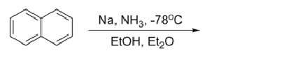
- Complete the reaction. (2)

