SARDAR BHAGWAN SINGH UNIVERSITY, BALAWALA, DEHRADUN
Session: 2019 – 2020
Assignment – 7

School / Department : literature and language
Name of Course and Semester : BA English hons 2nd sem
:Subject : Media writing Code : 123

Fill in the blanks
1. Features of a news article contains headline, ........,......,........
2. Headline should be catcy and .......
3. In main body use ....... To show transition.
4. The main body should have 5Ws and 1H, they are...
5. Ending quotes can be taken from relatives,...,....

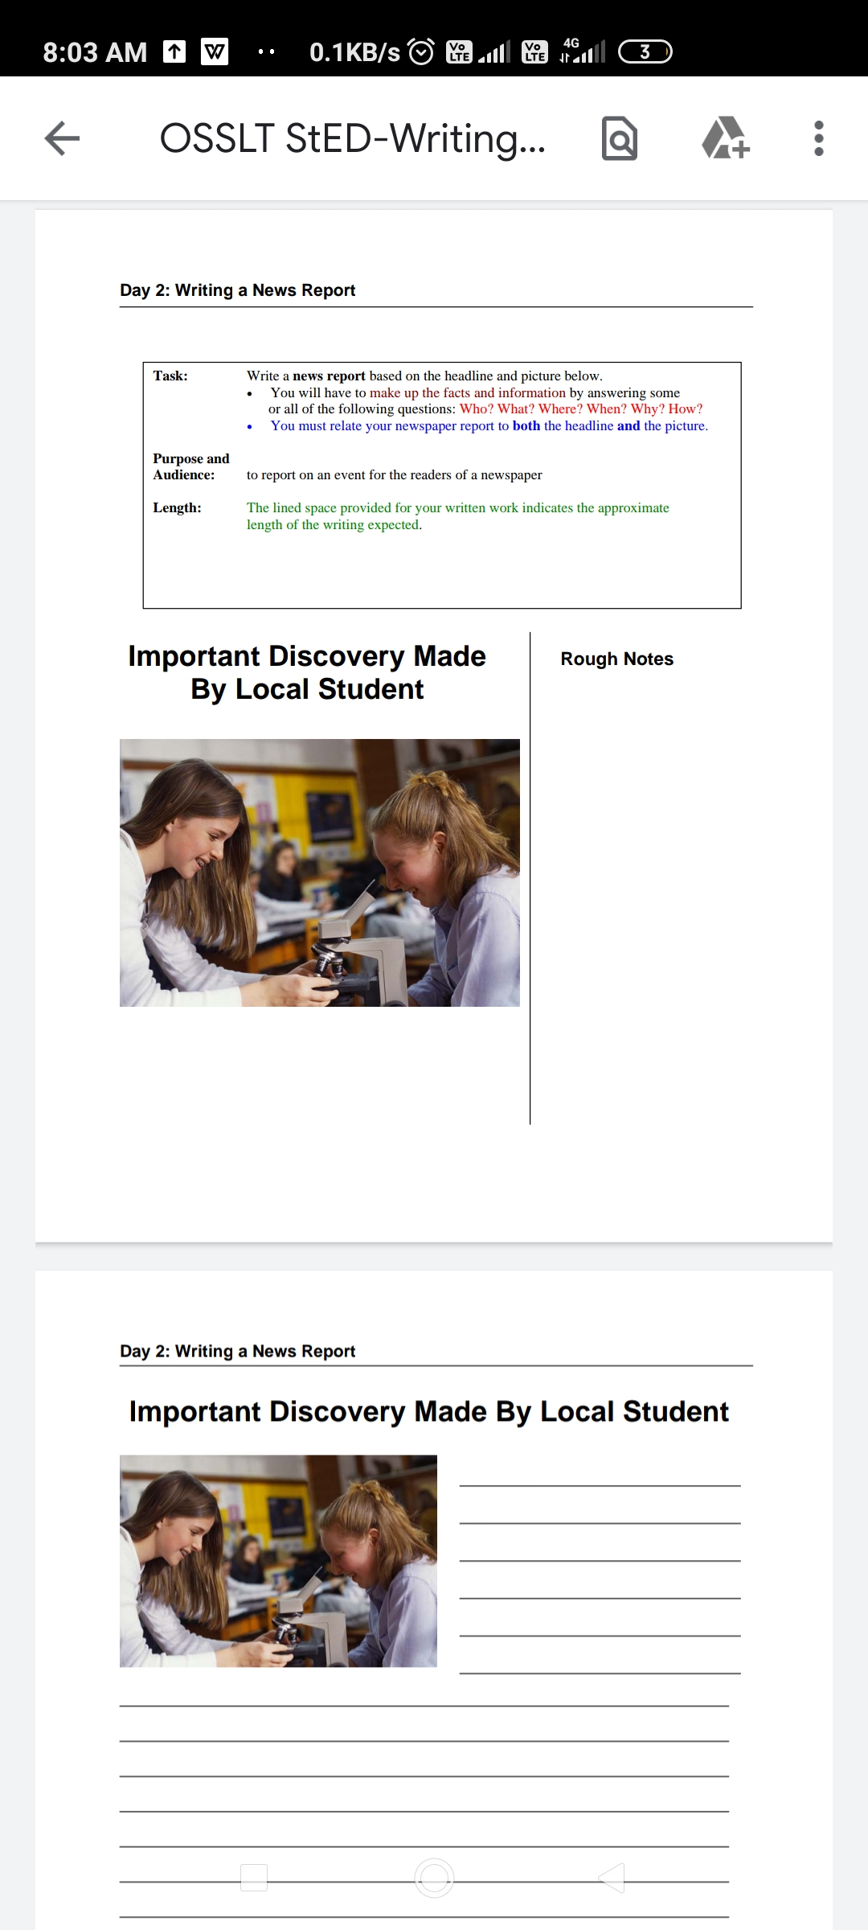
Long answer questions

