Sardar Bhagwan Singh University, Dehradun
School of Pharmaceutical Sciences & Technology
B. Pharm IV Semester Assignment No. 8

Subject: Pharmaceutical Organic Chemistry

Total Marks: 10

1 .Complete the reactions. (5)

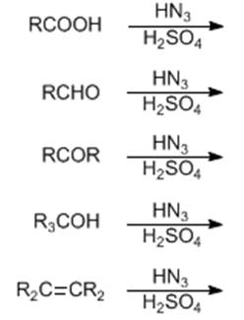
2. The reaction between an aldehyde/ketone and an aromatic carbonyl compound
lacking an ………….hydrogen (cross aldol condensation) is called
the ………….. (2.5)

3. Acid-catalyzed addition of hydrazoic acid to carboxylic acids, aldehydes and
ketones to give amines, nitriles and amides, respectively is known as …………..
reaction. (2.5)

